Advantages:

1. Create quick automation test cases.
2. Can be use for web, mobile and api testing.
3. Can be integrated with JIRA(proj management tool), git(version control system), Jenkins(CI CD Integration).
4. No code/less coding knowledge required.
5. Manual testers can start using it right away- learning curve is very short.

Tests explorer will have all these folders.

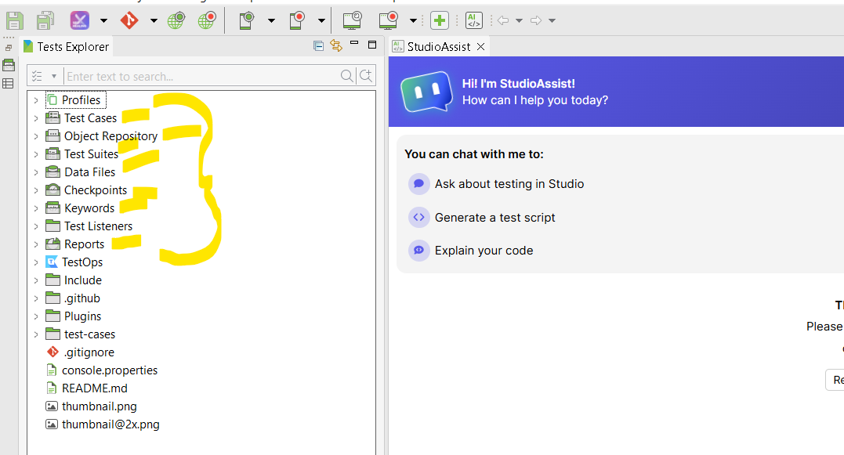

Test cases- we will be writing our tc’s here.

Object repository- where object of every element will be created.

Test suites- where tc’s will be stored.

Data files- where we will be storing our excel sheets.

Checkpoints- where we will be adding checkpoints to our tc’s.

Keywords- The ones that we are going to add or the ones we create on our own.

Test listeners- will help to set test execution- behaviour of the outputs.

Reports- will get reports of test case execution.

3 ways to create Automation tests:

1. Record and replay,
2. Manual mode.
3. Script mode.

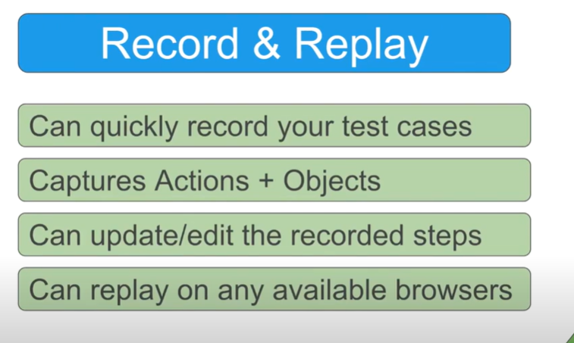

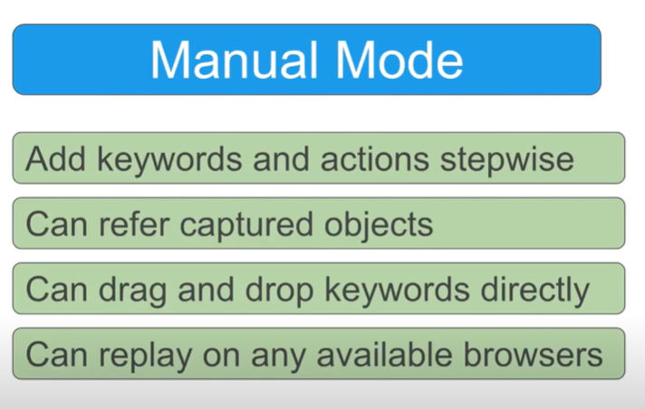

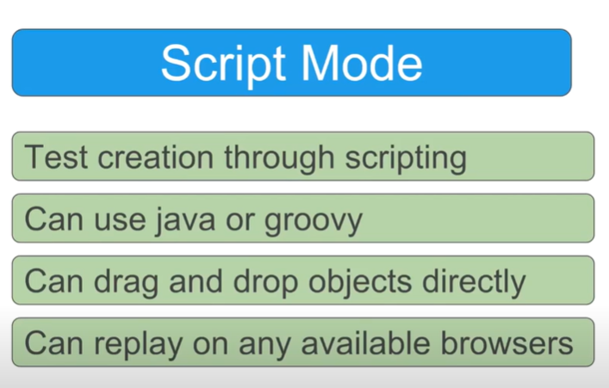

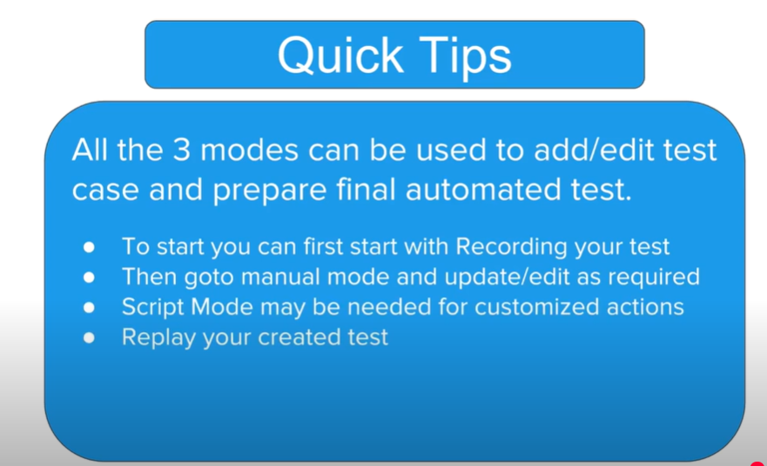

1. Create a new project.



1. How to write test cases in record mode:

Click Record web- on toolbar.

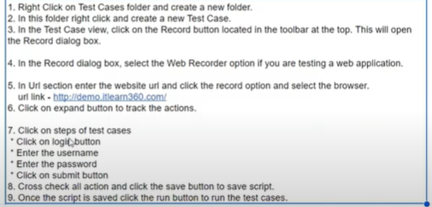

1. How to write test cases in Manual mode:

Click Spy web button on toolbar.- Capture objects manually. Manuall add items and values- Items like navigate to url, Open Browser are auto populated.

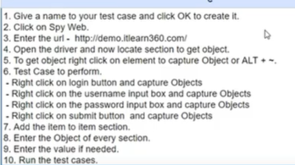

1. How to write test cases in Script mode:

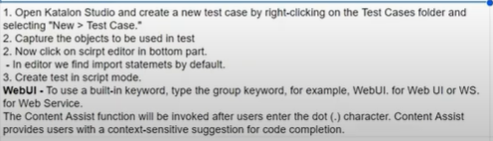

Script will look as following for login functionality.

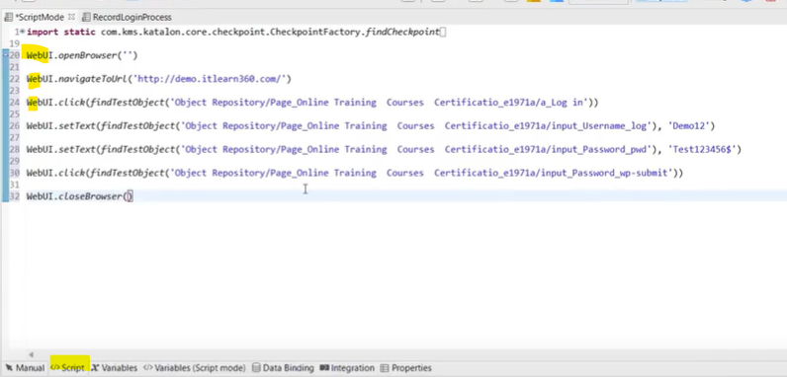

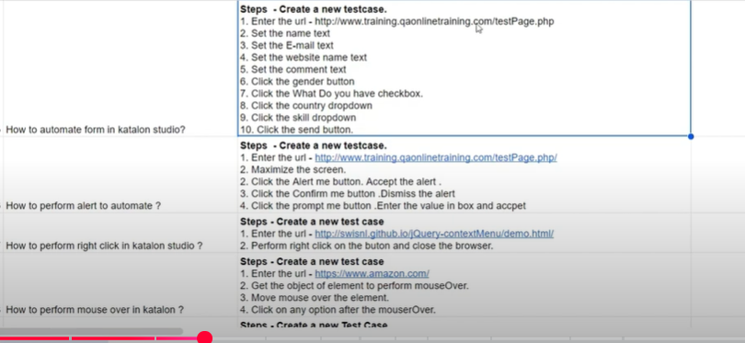

For alerts- when you record and replay, the alert pop up closes immediately and you can’t capture objects in record and replay mode. So you have to add the steps manually as below.

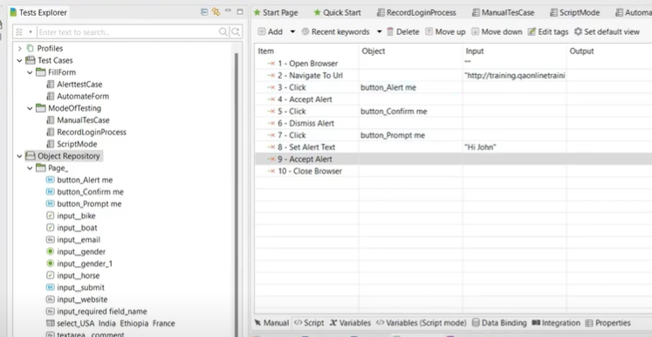

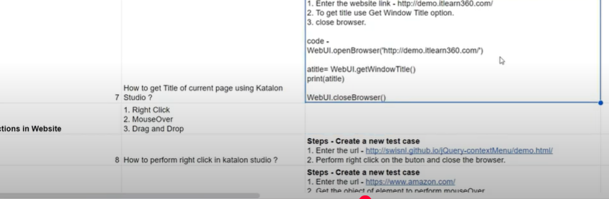

To get the Title of the page, we need to write the script manually using Getwindow title method, Then in script mode, save the title to a variable and print title as below if needed.

Script mode:

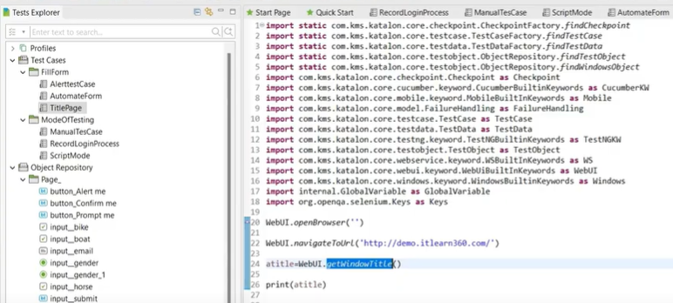

Manual mode for get title:

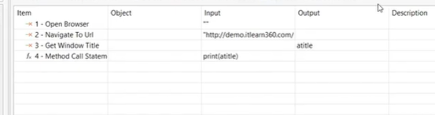

Actions:

Right click: Record and replay mode- click and save the objects.

Then need to go to manual mode and we see that its only saved as Click- change that to right click and we are good to go.

Mouseover:

Record and replay mode- perform actions and save the objects.

Then need to go to manual mode and we see that its only saved as Click- change that to Mouse over and we are good to go.

Drag and drop:

Iframe- drag drop obj is not part of the web page but part of iframe.

Click on the drag object(source)- press ctrl+alt+’”(not sure abt this shortcut) and capture the objects- both source and taget.

Then in manual mode go and change as follows.need to give both source and destination values.

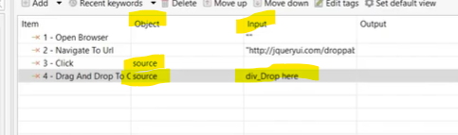

How to automate test suite: advantages- even if test case fails it will retry by itself. You can even choose to skip test cases by selecting the tc we want to skip.

To create suite, add previously created test cases to it.o to reports- auto generated.

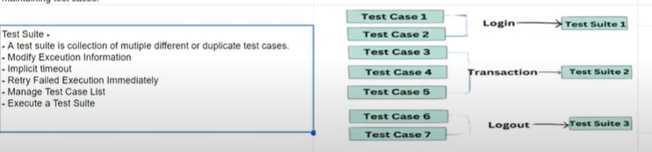

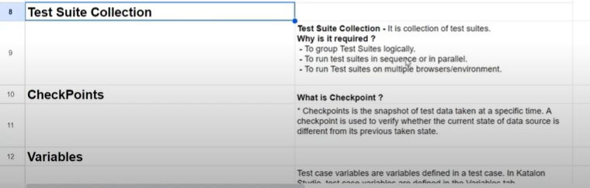

Test Suite Collection- To run this collection you need to click on EXECUTE button and NOT RUN Button.

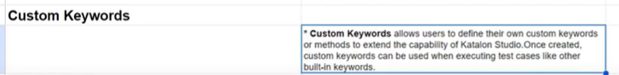

Custom keywords are created to find if all the elements are present or not – For ex: a dropdown.

Go to Keywords folder- new package- name it, ex: com.utilities

Go to script method – remove default sample keyword script and write below:

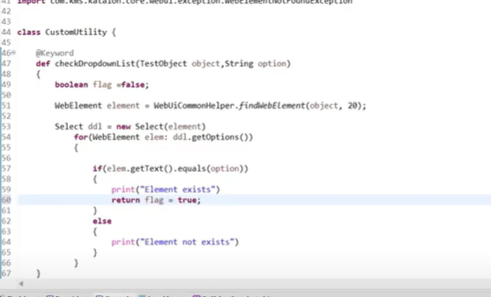

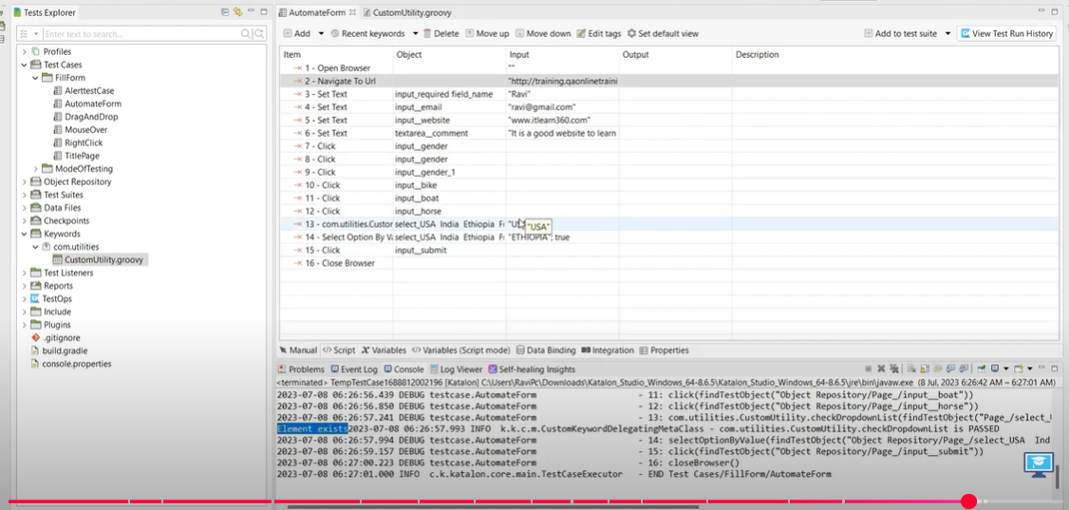

How to read data from excel sheet:

